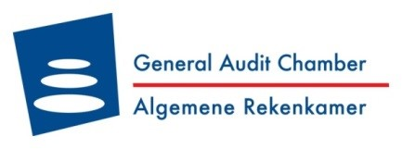

“Only 5.8% from Trust Fund spent on projects at the end of 2019”

Philipsburg – May 20th, 2020. Today, the General Audit Chamber presented its report entitled “Focus audit on the reconstruction funds for St. Maarten” to Parliament.

The focus audit is a new type of audit. Only facts are presented; recommendations and conclusions are not issued.

Based on their review, the General Audit Chamber determined that at the end of 2019, 5.8% of the total funds made available, were disbursed for projects.
The challenge for the near term is ensuring the acceleration of disbursements. In the event money is still available in the Fund after 2025 and the Fund ceases to exist, the World Bank will return the remaining amount to the Netherlands.
An above-average hurricane season is expected in 2020. In combination with the COVID-19 crisis, all parties involved face the increased challenge of getting homes, schools, and shelters hurricane-ready.
The report is published in both English and Dutch and is available on the website of the General Audit Chamber (www.arsxm.org) and on the institution’s Facebook and LinkedIn pages.
########

